Name: Class: Mark:

1. A secondhand car dealer keeps a database of cars for sale. A sample of the data is shown below. The table below is named Cars.
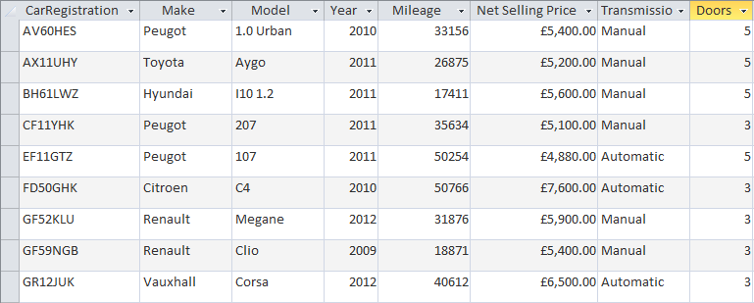
(a) State the registration number of the cars that will be found using each of the following criteria:
Mileage < 20000 [2]

Year >= 2011 and Transmission = 'Automatic' [2]

(Make = 'Peugeot' OR Make = 'Renault') AND (Net Selling Price <= 5200.00) [2]

(b) Write the SQL statement which will display the registration numbers and make of
all cars with 5 doors made in 2011 or after. [3]

2. A school keeps a record of all the school trips that take place each school year. An extract from the table Trips is shown below:
Trip ID | Description | StartDate | EndDate | Destination | NumberOf Students
14 | DofE Gold Expedition | 09/04/2014 | 13/04/2014 | Wales | 30
15 | Year 7 Castles Trip | 01/05/2014 | 01/05/2014 | Framlingham | 87
16 | Year7 Geography Field Trip | 07/05/2014 | 07/05/2014 | Walton-on-the-Naze | 91
17 | Prefects Leadership weekend | 20/06/2014 | 23/06/2014 | Bradwell | 15
18 | Spanish Taster Trip | 26/06/2014 | 30/06/2014 | Santander | 27
(a) Write an SQL query to find all trips in the Trips table where the number of students going is greater than 60. The Results table should display the columns labelled Description, StartDate, EndDate, Destination and NumberofStudents.
Records should be sorted by the number of students in descending order. [4]

(b) State which field will be the primary key in this table. [1]

(c) Complete the table below to show suitable data types for each of the fields given. [3]
Field name | Data type
StartDate
NumberOfStudents
Destination
(d) The school has a capacity for 1000 students. No trip will ever go ahead with
more than this number of students.
Give a suitable validation for the NumberOfStudents field. [1]

[Total 18 marks]

